**Overview:** To provide a high-level summary of customer behaviour, especially churn in one glance. It highlights key metrics, visual breakdowns, and overall trends.

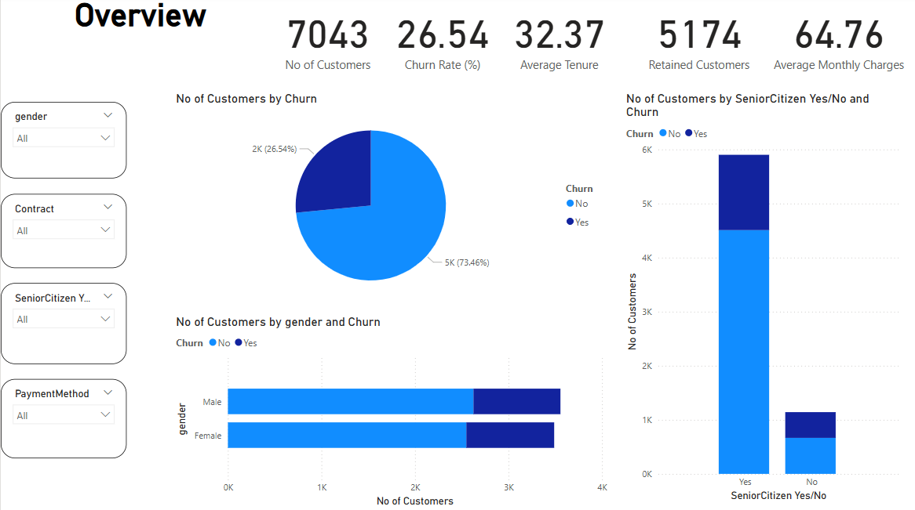

* Churn rate is 26%, highest among Month-to-Month contract users.
* Female customers have a slightly higher churn rate.
* Average tenure is 32 months — indicating a healthy retention period.

**Customer Demographics Analysis:** This page gives insights on who your customers are, and which demographic segments are more likely to churn.

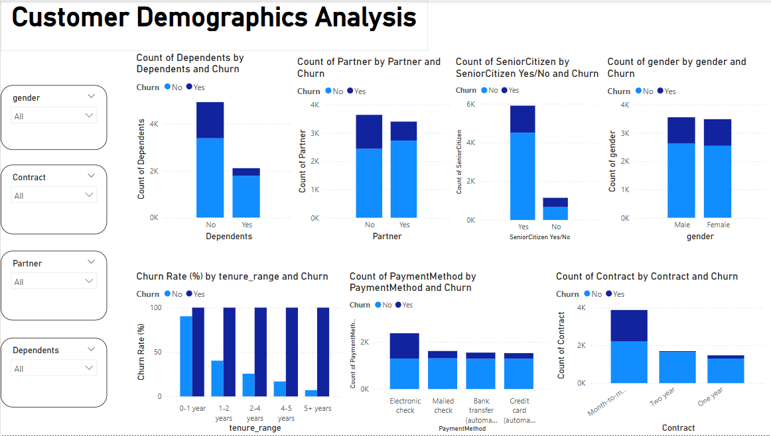

**Service Usage Pattern:** To find out if using more services makes a customer less likely to churn (more engaged), or vice versa.

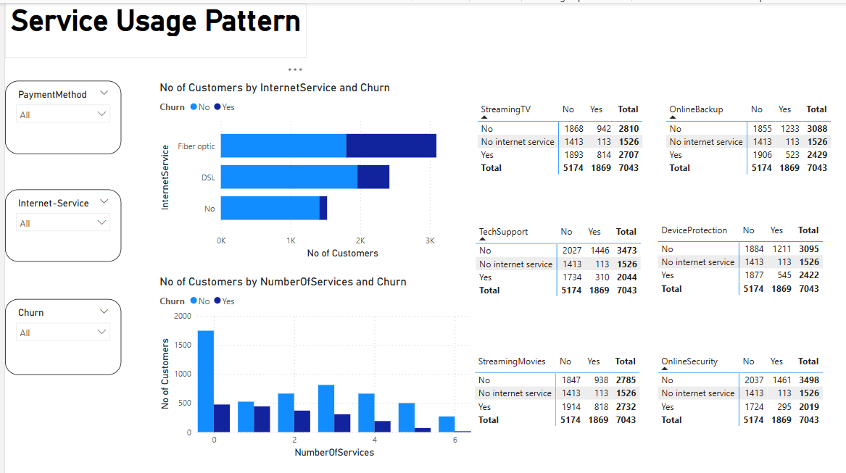

**Financial Impact:** To find how frequently customers gets churned and Helps to see whether churned customers were paying more or less monthly.

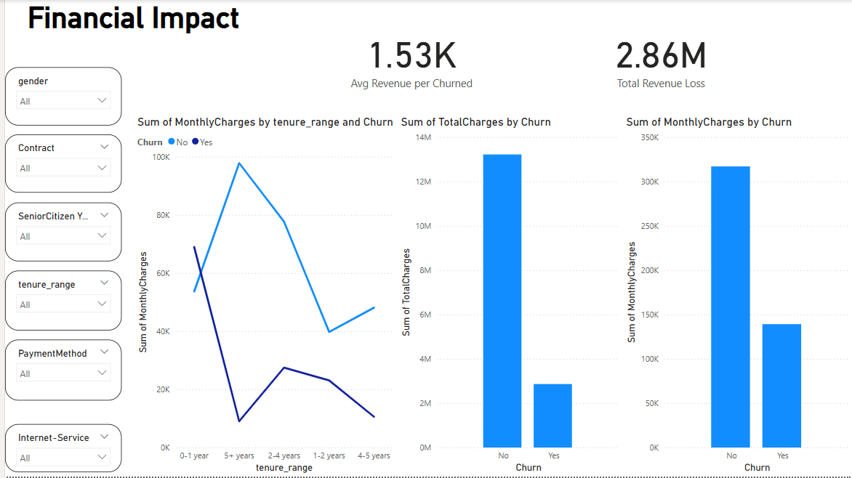

**Final Dashboard:**

